 TAGORE ENGINEERING COLLEGE 

# SB8055 – BLOCK CHAIN DEVELOPMENT

|  |  |
| --- | --- |
| DATE | 30 OCTOBER 2023 |
| TEAM ID | NM2023TMID010104 |
| PROJECT NAME | REAL ESTATE USING BLOCKCHAIN TECHNOLOGY |

|  |  |
| --- | --- |
| TEAM LEADER | C.SATHISH |
| TEAM MEMBER 1 | N. SATHISH |
| TEAM MEMBER 2 | M.DINESH |
| TEAM MEMBER 3 | M.SARAVANAN |

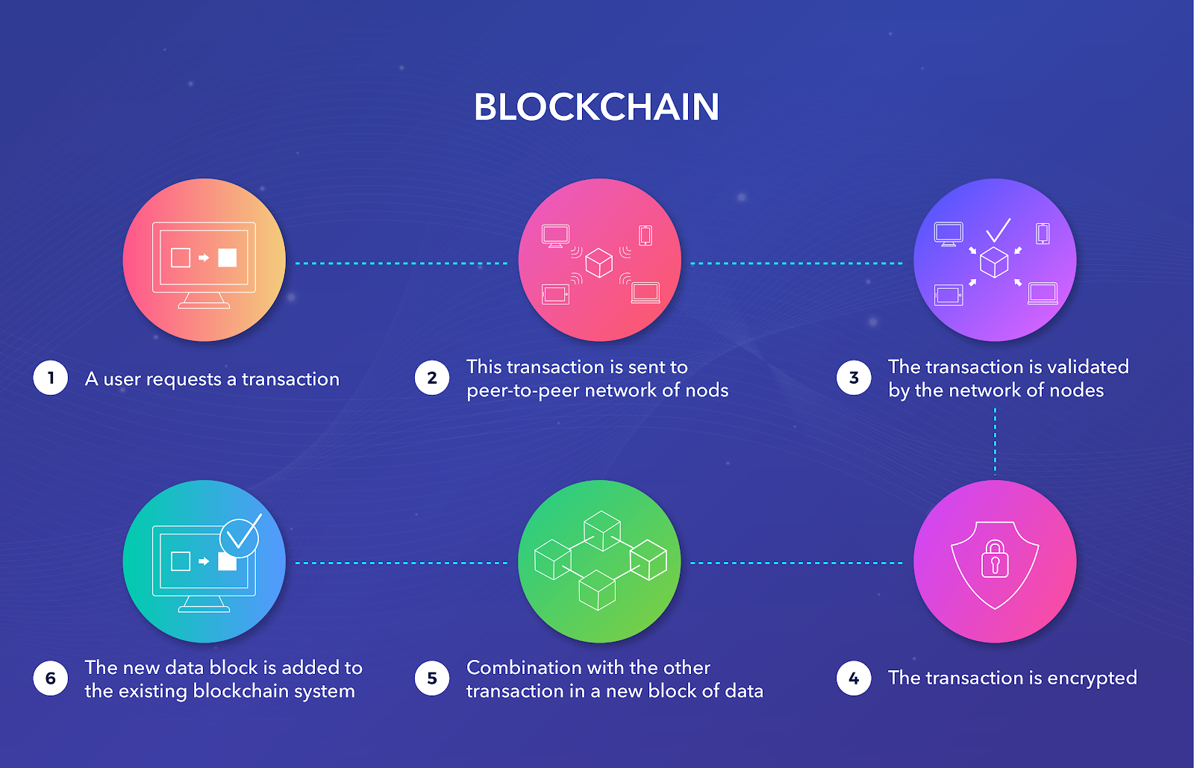

**REAL ESTATE USING BLOCKCHAIN TECHNOLOGY**

|  |  |
| --- | --- |
| Date | 26 OCTOBER 2023 |
| Team ID | NM2023TMID01014 |
| Project Name | REAL ESTATE USING BLOCKCHAIN TECHNOLOGY |

**1.INTRODUCTION:**

**BLOCK CHAIN:**

Blockchain technology is an advanced database mechanism that allows transparent information sharing within a business network. A blockchain database stores data in blocks that are linked together in a chain. The data is chronologically consistent because you cannot delete or modify the chain without consensus from the network. As a result, you can use blockchain technology to create an unalterable or immutable ledger for tracking orders, payments, accounts, and other transactions

**1.1 PROJECT OVERVIEW**

The real estate sector in Pakistan is one of the most lucrative industries in the world with returns growing higher every year, even considering the unstable political conditions that prevail over the country due to the abundant corruption among numerous sectors in the country. Real estate sector is no exception to this sad reality. One of the main reasons for this corruption is the incorrect values of the real estate which are recorded as the government organizations which record land transactions of different areas of the country. This can be combatted with the correct recording of the value of these properties so that all parties are aware of the prices; this is where the block chain comes in. The block chain is a distributed ledger for record keeping in which all the transactions can be viewed by anyone on the block chain and even observers from outside the block chain can view these transactions and their value. That means it’s a technology which is formed around open data which is accessible to numerous users on the network and even to users who are not a part of the network making it much like a public market place, much more detailed than a stock market or a foreign exchange market.

**PROBLEM STATEMENT**:

Lack of Transparency the real estate market often lacks transparency, with property data, transaction history, and ownership records scattered across various databases and paperwork. This opacity makes it difficult for buyers, sellers, and other stakeholders to obtain reliable and up-to-date information. High Transaction Costs: Real estate transactions involve numerous intermediaries, such as real estate agents, title companies, and notaries. These intermediaries charge fees and commissions, significantly increasing the overall transaction costs for both buyers and sellers. Complex and Time-Consuming Processes: Real estate transactions are typically complex, involving lengthy and time-consuming processes. This can lead to delays, human errors, and a lack of standardization in agreements and documentation. Fraud and Forgery Risks: Traditional paper-based documentation and manual verification processes are vulnerable to fraud and forgery. Property records, titles, and agreements can be manipulated or forged, potentially leading to financial losses and disputes. Data Inefficiency: Real estate data, including property records and transaction history, is often siloed, which can lead to data inefficiency, redundancy, and inaccuracies. Limited Access to Investment Opportunities: Traditional real estate investment often requires significant capital for full property ownership. This can limit investment opportunities for smaller investors or those interested in fractional ownership.

**1.2 PURPOSE:**

The geographic distribution is chosen due to fact that this paper wants to determine the impact of the block chain technology on not only consumers but also on the economic implications that it would have on the real estate sector in Karachi, Pakistan as the real estate sector in Karachi is worth billions of rupees and the impact if the block chain would be implemented would be massive and which would affect millions of people residing in the city as well as investors abroad. The methodology which will be applied for this research paper is by making a questionnaire which would be a universal one and would be filled out by real estate agents, developers, investors, people who are currently working on the block chain technology in Pakistan as well as people in the fintech space working in Pakistan. Once that is complete, the data collected with analyzed using the latest SPSS software. SPSS stands for Statistical Package for the Social Science. It is the most well-known software used for analysis of data and has been used in numerous studies across the globe. It can perform all kinds of analysis as well as handle large amounts of data. Therefore, the research design was formed by deciding on the objectives of the study which included block chain implementation first and then moving on to the research questions with followed. This led to the development of the hypothesis and the questions being researched upon. Next came the data collection and then analyzing the data through the latest version of the SPSS Ver. 23 software and checking it through the correlation test to get the results which then led to the conclusion and recommendations on the topic. This research conducted in Positivism Paradigm, and Pure Quantitative research based available constructs. The research is explanatory based on selected independent and dependent variables we will explain the relationship of effect on Block chain and real estate. The research conducted through Questionnaire adapted from previous empirical researches.

**2. LITERATURE SURVEY:**

**2.1 EXISTING PROBLEM:**

As of my last knowledge update in January 2022, blockchain technology had made significant progress in addressing some of the challenges in the real estate industry, but there were still some existing problems and limitations. It's important to note that the adoption and development of blockchain technology in real estate may have evolved since then, but here are some of the existing problems as of that time.

Regulatory and Legal Challenges: Real estate is subject to complex and varying regulatory requirements in different regions. Blockchain applications must align with existing legal frameworks, which can be a challenge. Ensuring compliance with Know Your Customer (KYC) and Anti-Money Laundering (AML) regulations can be particularly difficult.

Interoperability: Different blockchain platforms and protocols may not be compatible with each other. This can lead to fragmentation in the real estate blockchain ecosystem, making it challenging for different parties to interact and share data seamlessly.

Standardization: The absence of standardized data formats, smart contract templates, and industry-wide practices can lead to inconsistencies in how property information is represented and processed on the blockchain.

**2.2 REFERENCE:**

Eyal, I., Gencer, A. E., Sirer, E. G., & Renesse, R. v. (2016). Bitcoin-NG: A Scalable Blockchain Protocol. Santa Clara: Cornell University.

Friedlmaier, M., Tumasjan, A., & Welpe, I. (2017). Disrupting Industries with Blockchain. Munich: Technische Universität München (TUM) – TUM School of Management.

Hillbom, E., & Tillstrom, T. (2016). Applications of smart-contracts and smart property using Block chain. Gothenburg: University of Gothenburg.

Amadeo, K. (2017, June 10). Real Estate: What It Is and How It Works. Retrieved from The Balance: https://www.thebalance.com/real-estate-what-it-is-and-how-it-works-3305882 Atzori, M. (2015). Blockchain Technology and Decentralized Governance. University College of London.

Bal, M. (2017). Securing Property Rights in India Through Distributed Ledger Technology. New Delhi: Observer Research Foundation.

Blockgeeks. (2015, May 1). Smart Contracts: The Blockchain Technology That Will Replace Lawyers. Retrieved from Blockgeeks: https://blockgeeks.com/guides/smart-contracts.

Christidis, K., & Devetsikiotis, M. (2016). Blockchains and Smart Contracts for the Internet of Things. North Carolina: IEEE.

Crosby, M., Nachiappan, Pattanayak, P., Verma, S., & Kalyanaraman, V. (2016). BlockChain Technology: Beyond Bitcoin. Berkely : Berkely University.

CSIRO. (2017). Risks and Opputunities for Systems Using Blockchain and Smart Contracts. Sydney: CSIRO.

Dictionary.com. (n.d.). Record keeping. Retrieved from Dictionary.com: http://www.dictionary.com/browse/recordkeeping.

Harker, P. T. (2017). Fintech: Revolution or Evolution? Pennsylvania: University of Pennsylvania School of Engineering.

Investopedia. (2015, January 1). Block chain. Retrieved July 29, 2017, from Investopedia:

http://www.investopedia.com/terms/b/blockchain.asp.

Kevin Delmolino, M. A. (2015). Step by Step Towards Creating a Safe Smart Contract. Maryland: University of Maryland.

Malviya, H. (2015). Blockchain for Real Estate. itsblockchain.com.

.

**2.3 PROBLEM STATEMENT DESCRIPTION:**

AUTHOR:Speilman

YEAR:2016

PROJECT DESCRIPTION:The world over, researchers claim that the block chain technology is how people in the future, will be keeping records and histories of transactions and events and which would be very beneficial if it was applied to the property sector but acceptance will take time as it’s a new technology and can be complicated and as yet, the benefits do not outweigh the costs for implementing such a technology. Explaining block chain to people with little or no knowledge of technology can be a daunting task as it is really very difficult to assess where the exact or let’s say correct starting point would be. One the easiest explanation is that is a tool for record keeping and managing information about the transactions being conducted on that specific network.

AUTHOR:Maximilian Friedlmaier

YEAR:2016

PROJECT DESCRIPTION:Agreed upon by numerous technology gurus and researchers, the block chain technology has the potential to disrupt many outdated business models which rely heavily on accurate record keeping. Numerous startup and venture capital funds and not to forget bug corporations are funneling money into the research of the applications of the block chain technology and how it can be applied to their industry. In the case of a decentralized and distributed database, much like the database that the crypto currency Bitcoin operated on, everyone has possession of the complete copy of the database

AUTHOR:Kevin Delmolino

YEAR:2015

PROJECT DESCRIPTION:Smart contracts are although programmed much like the normal programming languages used today but differ in the way that they are user defined programs that stipulate regulations in transactions of the underlying asset. Also, compared to outmoded financial or real estate contracts, they would have lower legal and transactional fee and might be able to lower the barriers for entry of new users.

AUTHOR:Christidis & Devetsikiotis

YEAR:2016

PROJECT DESCRIPTION:A block chain network has the unique attribute that allows is to not only have a distributed ledger but allows non-trusting members of the network to transact and interact with each other without the need of a trusted intermediary while still being easy to verify whenever the need be. A very useful and significant feature of the block chain is the use and exchange of assets of value through smart contracts which enable transactions with the underlying assets being of significant value. Therefore, the block chain is a revolutionary part of the internet of things and especially for the world we live in as the technological advances are coming at such a rate that it can be difficult to keep track. Thus, the block chain technology and smart contracts indeed do have the potential to pave the way for, not only new processes inside organizations but also innovative business models using distributed applications to drive business in the years to come

**3. IDEATION AND PROPOSED SOLUTIONS:**

**3.1 Empathy Map Canvas:**

An empathy map is a simple, easy-to-digest visual that captures knowledge about a user’s behaviours and attitude.

It is a useful tool to helps teams better understand their users.

Creating an effective solution requires understanding the true problem and the person who is experiencing it. The exercise of creating the map helps participants consider things from the user’s perspective along with his or her goals and challenges.

**Example:**

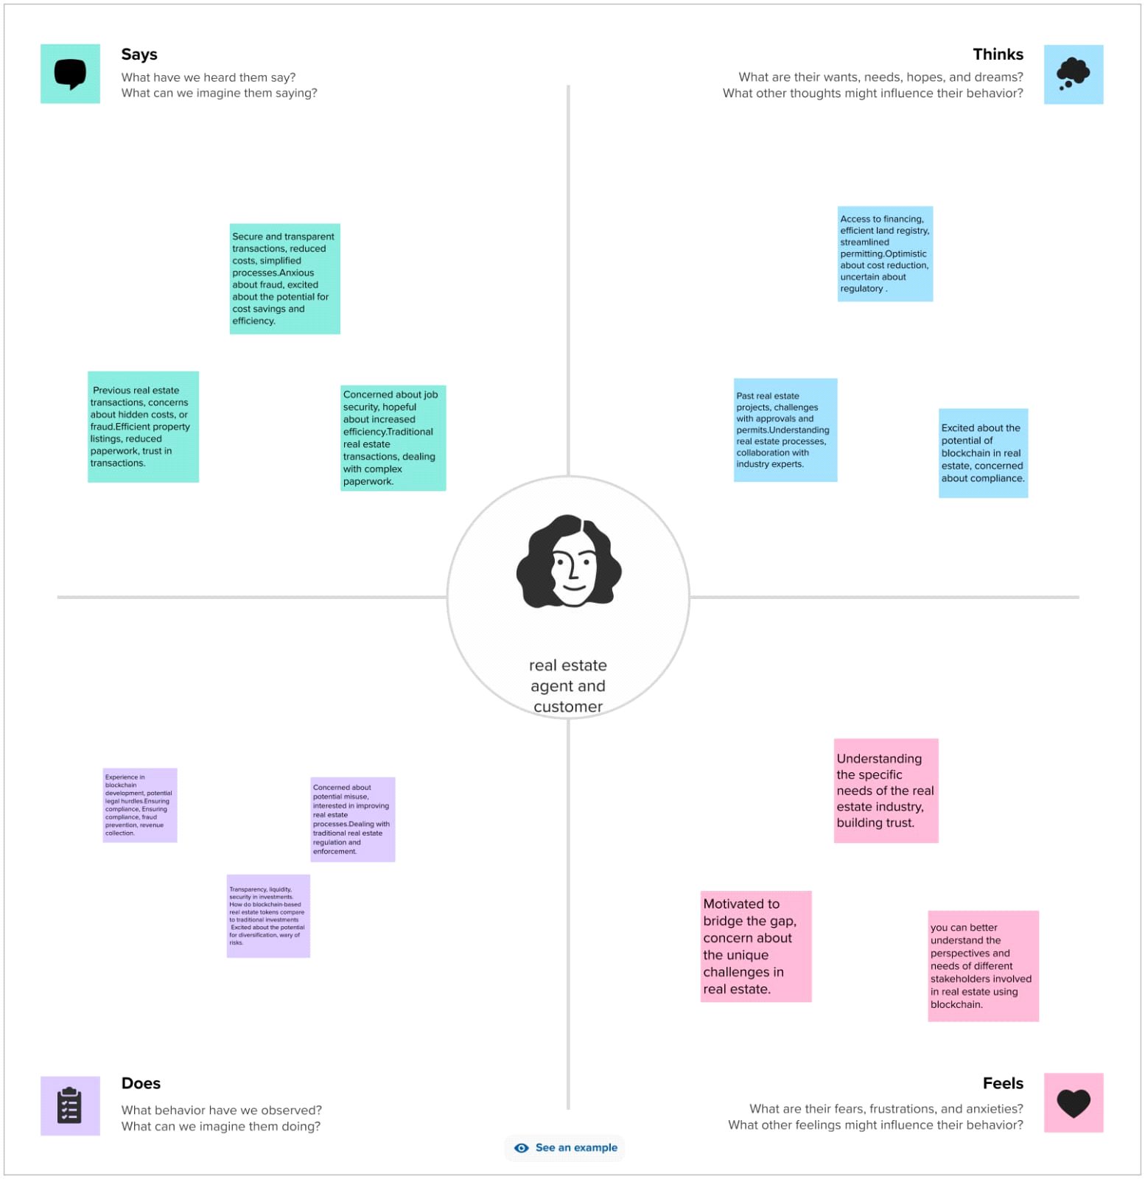

**3.2 Brainstorm & Idea Prioritization:**

Brainstorming provides a free and open environment that encourages everyone within a team to participate in the creative thinking process that leads to problem solving. Prioritizing volume over value, out-of-the-box ideas are welcome and built upon, and all participants are encouraged to collaborate, helping each other develop a rich amount of creative solutions.

Use this template in your own brainstorming sessions so your team can unleash their imagination and start shaping concepts even if you're not sitting in the same room.

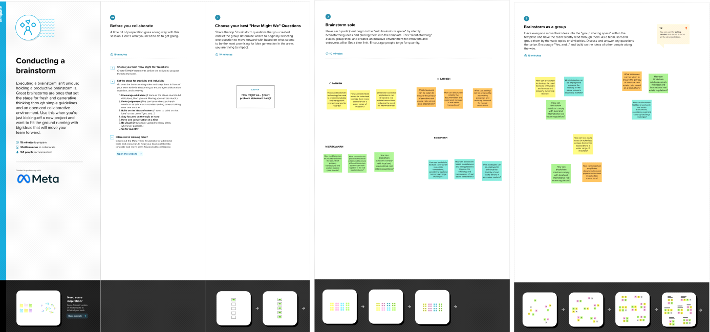

**PROBLEM STATEMENT**:

|  |  |  |  |  |  |
| --- | --- | --- | --- | --- | --- |
| **Problem statement** | **I am** | **I am trying**  **to** | **but** | **because** | **Which makes me**  **feel** |
| **Ps-1** | real estate agent | maintain the records from the seller and provide it to the buyers | By minimizing the involvement of intermediaries and automating various processes, blockchain should significantly lower transaction costs, making real estate transactions more affordable. | Blockchain's cryptographic features should protect against fraud and manipulation of property records, ensuring that my investments and property rights are secure. | In summary, I anticipate that blockchain technology will address these customer concerns, improving the real estate experience, making it more secure, cost-effective, and accessible for all participants." |

|  |  |  |  |  |  |
| --- | --- | --- | --- | --- | --- |
| **Ps-2** | customer | These criteria encompass various dimensions: product performance, service reliability, ease of use, value for money, and emotional connection. Customers are more likely to feel satisfied, develop loyalty, and advocate for the brand when these customer expectations are met or exceeded. | The current real estate system lacks transparency, making it difficult to trust property listings and information provided by sellers and agents. This uncertainty often leads to skepticism and caution when making real estate decisions. | Real estate transactions are notorious for their complexity and the time it takes to complete them. The involvement of multiple intermediaries, paperwork, and manual processes often results in delays and confusion. | The risk of fraud and misrepresentation in real estate is significant. Forgery, manipulation of property records, and deceitful practices by unscrupulous actors can lead to financial losses and legal issues. |

**4. REQUIREMENT ANALYSIS:**

**4.1 FUNCTIONAL REQUIREMENTS:**

Functional requirements outline the specific functions and capabilities the blockchain-based real estate process

|  |  |  |
| --- | --- | --- |
| **FR NO** | **Functional requirements** | **Subrequirement** |
| FR-1 | Property Registration | Users should be able to register their properties on the blockchain.  Include property details such as address, owner's information, and any other relevant information. |
| FR-2 | Property Transfer | Allow property owners to transfer ownership to another party by updating the contract.  Ensure that the transfer is secure and verifiable. |
| FR-3 | Property Query | Enable users to query property details from the blockchain by providing the property’s unique identifier. |
| FR-4 | Contract Validation | Ensure that all transactions adhere to legal and regulatory requirements, including any necessary approvals or permits. |
| FR -5 | Ownership Verification | Implement a method for verifying the ownership of a property by querying the blockchain. |
| FR-6 | Multi-signature Support | Support multi-signature capabilities for transactions, ensuring consensus among multiple parties for significant changes in ownership. |
| FR-7 | Escrow Services | Facilitate escrow services for property transactions, ensuring that funds are released only when predefined conditions are met. |

**4.2 NON FUNCTIONAL REQUIREMENTS:**

Non-functional requirements define the quality attributes, constraints, and criteria that the system must meet.

|  |  |  |
| --- | --- | --- |
| **NFR NO** | **Non-Functional requirements** | **Subrequirement** |
| NFR-1 | Security | The smart contract system must be highly secure to prevent unauthorized access, tampering, or data breaches. It should use industry best practices for security. |
| NFR-2 | Scalability | The system should be capable of handling a growing number of real estate contracts and property transactions without compromising performance. |
| NFR-3 | Interoperability | Ensure compatibility with other blockchain-based systems and standards to enable seamless interactions with external services or applications. |
| NFR-4 | Usability | The user interface for interacting with the smart contract should be intuitive and user-friendly, making it accessible to a wide range of users, including non-technical individuals. |
| NFR-5 | Performance | The smart contract should execute transactions and queries efficiently and without significant delays. |
| NFR-6 | Reliability | The system must be reliable, with minimal downtime or disruptions to ensure continuous availability for users. |
| NFR-7 | Cost Efficiency | Minimize gas fees associated with Ethereum transactions to keep costs reasonable for users and property owners. |

**5.PROJECT DESIGN:**

**5.1 DATA FLOW DIAGRAM AND USER STORIES:**

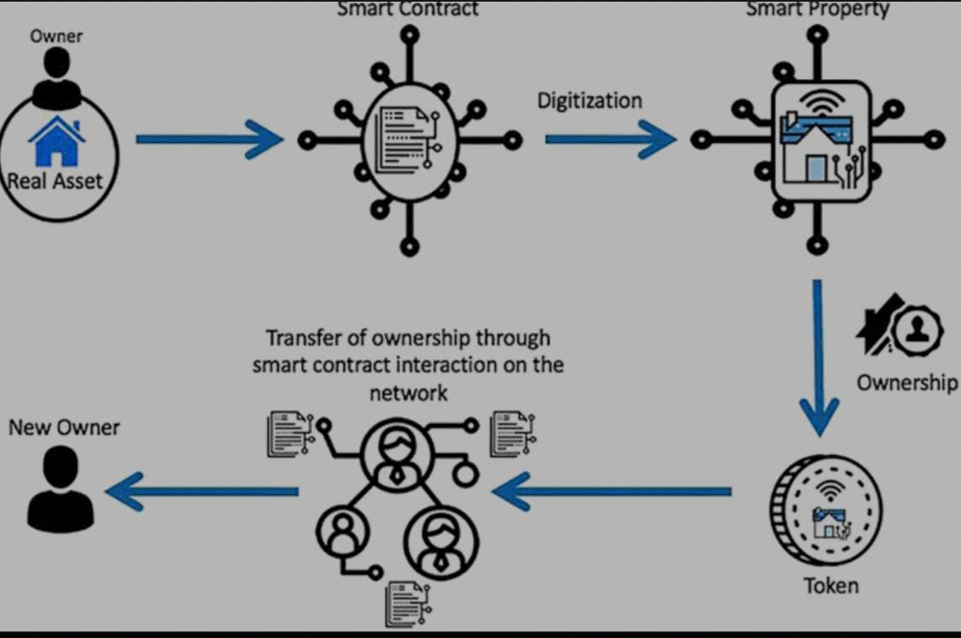

A flow diagram of real estate transactions using blockchain technology can be a powerful visualization of how this innovative technology can streamline and secure various aspects of the real estate industry. Here's a simplified theoretical flow diagram outlining the key steps involved: Property owners or agents list the property on a blockchain-based real estate platform. Property details, including images, documents, and descriptions, are uploaded to the blockchain

Characteristic of blockchain technologies Some key characteristic of blockchain technologies are listed as follows:

Property Listing:Property owners or agents list the property on a blockchain-based real estate platform.Property details, including images, documents, and descriptions, are uploaded to the blockchain.

Property Verification:Property information is verified and validated by a network of nodes on the blockchain.Ownership records, permits, and zoning information are cross-referenced to ensure accuracy.

Smart Contracts Creation:Smart contracts are created to outline the terms and conditions of the transaction, such as price, payment schedules, and other contingencies.These smart contracts are stored on the blockchain and automatically executed when conditions are met.

Buyer Registration:Potential buyers create a digital identity on the blockchain.KYC (Know Your Customer) and AML (Anti-Money Laundering) checks are performed, ensuring the legitimacy of the buyer.

Property Viewing and Offers:Interested buyers can view the property details, schedule viewings, and make offers through the blockchain platform.Offers are made using digital tokens or cryptocurrencies.

**USER STORIES :**

|  |  |  |  |  |  |  |  |  |
| --- | --- | --- | --- | --- | --- | --- | --- | --- |
| **User Type** | **Functional**  **Requirement**  **(Epic)** | | **User Story**  **Number** | **User Story / Task** | | **Acceptance Criteria** | **Priority** | **Name** |
| Authorities | User Registration | | USN-1 | As a regulatory authority, I want to monitor real estate transactions for compliance with local laws and regulations. | | I can access the blockchain's transparent records to ensure tax compliance and adherence to real estate regulations. | High | Sathish.N |
| Real estate agent | Updating information | | USN-2 | | As a real estate agent, I want to use blockchain to verify property information. | I can quickly access property records and verify ownership, eliminating the need for time-consuming manual checks. | High | Sathish.C |
| Buyer | | Verification | USN-3 | | I can filter properties based on my preferences, such as location, price range, and property type, with confidence in the accuracy of the listings. | We can use the blockchain platform's secure messaging and communication channels to negotiate and come to a mutual agreement. | High | Dinesh |
| Seller | | Price comfort | USN-4 | | As a buyer and seller, we want to negotiate terms and conditions of the transaction securely. | I can easily upload property details, documents, and images, knowing that the blockchain will verify and validate the information for potential buyers. | High | Saravanan |

**5.2 SOLUTION ARCHITECTURE:**

Blockchain Network: Implement a private or consortium blockchain network, which ensures that only authorized participants (e.g., property owners, buyers, real estate agents) can participate in the network. Popular blockchain platforms like Ethereum, Hyperledger Fabric, or a purpose-built solution can be used.

User Interfaces: Build user-friendly web and mobile applications for different user roles, such as buyers, sellers, real estate agents, and property inspectors. These interfaces provide access to the blockchain network and allow users to interact with smart contracts.

Identity and Access Management (IAM): Implement IAM solutions to manage user identities, access control, and permission settings. This ensures that only authorized individuals can perform specific actions on the blockchain network.

External Data Integration: Connect with external data sources, such as property registries, government databases, and credit bureaus, to verify property information, ownership records, and conduct Know Your Customer (KYC) checks.

Tokenization (Optional): If fractional ownership is a feature, create a mechanism for tokenizing real estate properties. This allows properties to be divided into tokens that represent ownership shares and can be traded on the blockchain.

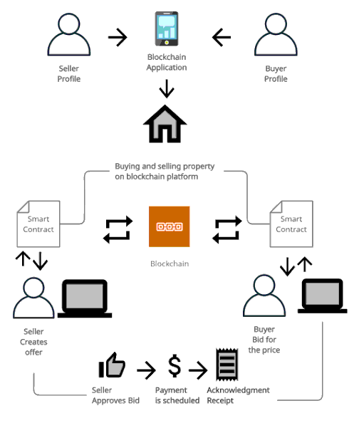

**6. PROJECT PLANNING AND ESTIMATION:**

**6.1 TECHNICAL ARCHITECTURE**

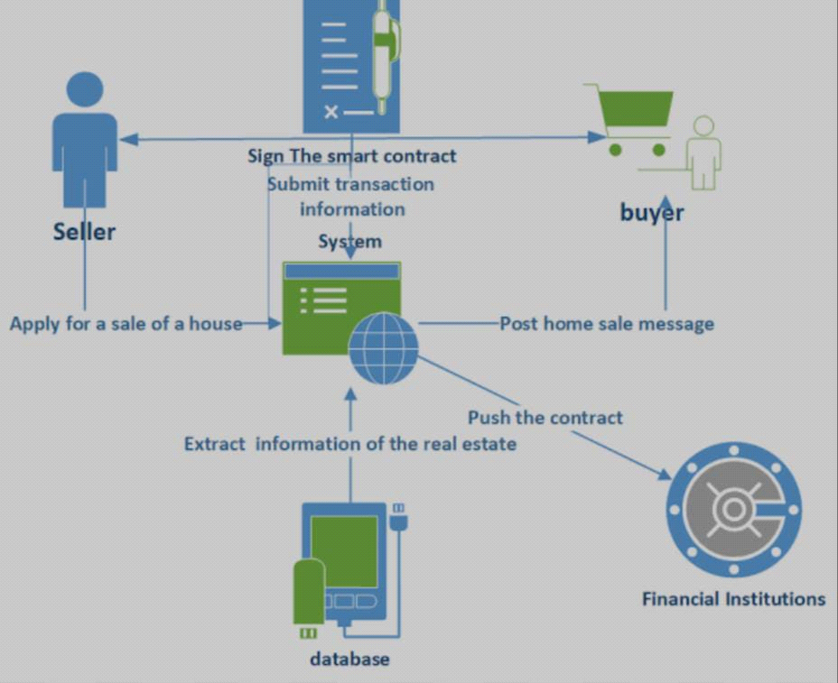

**6.2 SPRINT PLANNING AND ESTIMATION**

**SPRINT PLANNING**

|  |  |  |
| --- | --- | --- |
| **TITLE** | **DESCRIPTION** | **DATE** |
| Define the smart contract | Creat a new smart contract called realestate management on the ethereum blockchain | October 9 2023 |
| State variable | Define a state variable to store property deatails ,ownership , other relevant information | October 10 2023 |
| Register property | This fuction should accept deatails such as property address ,owners information and any other relavant data | October 11 2023 |
| Access control | Implement access control mechanisms to ensure that only authorized users can perform certain actions ,such as transferring ownership | October 15 2023 |
| events | Emit evints to log property registration and ownership transfer transaction for transparency and auditing | October 18 2023 |
| security | Implement security best protect against vulnerabilities and attacks | October 19 2023 |
| testing | Thoroughly test the smart contract on a testnet to ensure its functionality and security | October 19 2023 |
| deployment | Deploy the smart contract to the ethereum mainnet or a suitable testnet | October 19 2023 |

**ESTIMATION**

|  |  |  |  |  |  |  |
| --- | --- | --- | --- | --- | --- | --- |
| **Sprint** | **Functional Requirements** | **User Story Number** | **User Story/Task** | **Story Points** | **Priority** | **Team members** |
| 1 | Project planning and research | USN1 | Defiine project sope and objectives | 5 | high | Team lead |
| 2 | Smart contract design | USN2 | Creat detailed design of the smart contract, | 8 | medium | Team mem 01 |
| 3 | development | USN3 | Write and test the smart contract code | 3 | high | Team mem 02 |
| 4 | testing | USN4 | Comprehensive testing on ethereum test nets | 5 | high | Team mem 03 |
|  |  |  |  |  |  |  |

**6.2 SPRINT DELIVERY SCHEDULE :**

|  |  |  |  |  |  |  |
| --- | --- | --- | --- | --- | --- | --- |
| **Sprint** | **Total story points** | **duration** | **Sprint start date** | **Sprint end date** | **Story points completed(as on planned end date)** | **Sprint release date** |
| Sprint 1 | 20 | 3 days | Oct 9 | Oct 12 | 20 | Oct 12 |
| Sprint 2 | 20 | 3 days | Oct 13 | Oct 16 | 20 | Oct 16 |
| Sprint 3 | 20 | 3 days | Oct 17 | Oct 20 | 20 | Oct 20 |
| Sprint 4 | 20 | 3 days | Oct 21 | Oct 23 | 20 | Oct 23 |
| Sprint 5 | 20 | 3 days | Oct 24 | Oct 27 | 20 | Oct 27 |

**7. CODING AND SOLUTIONING:**

// SPDX-License-Identifier: MIT

pragma solidity ^0.8.0;

contract PropertyDetail{

address public owner;

struct Property {

string propertyId;

string name;

string location;

string discription;

address currentOwner;

}

mapping(string => Property) public properties;

mapping(address => mapping(string => bool)) public hasAccess;

event PropertyAdded(

string indexed propertyId,

string name,

string location,

address indexed owner

);

event PropertyTransferred(

string indexed propertyId,

address indexed from,

address indexed to

);

constructor() {

owner = msg.sender;

}

modifier onlyOwner() {

require(msg.sender == owner, "Only contract owner can call this");

_;

}

modifier hasPropertyAccess(string memory propertyId) {

require(

hasAccess[msg.sender][propertyId],

"You don't have access to this property"

);

_;

}

function addProperty(

string memory propertyId,

string memory name,

string memory location,

string memory _description

) external onlyOwner {

require(

bytes(properties[propertyId].propertyId).length == 0,

"Property already exists"

);

properties[propertyId] = Property({

propertyId: propertyId,

name: name,

location: location,

discription : _description,

currentOwner: owner

});

**hasAccess[owner][propertyId] = true;**

**emit PropertyAdded(propertyId, name, location, owner);**

**}**

**function transferProperty(**

**string memory propertyId,**

**address newOwner**

**) external hasPropertyAccess(propertyId) {**

**require(newOwner != address(0), "Invalid new owner");**

**address currentOwner = properties[propertyId].currentOwner;**

**properties[propertyId].currentOwner = newOwner;**

**hasAccess[currentOwner][propertyId] = false;**

**hasAccess[newOwner][propertyId] = true;**

**emit PropertyTransferred(propertyId, currentOwner, newOwner);**

**}**

**function getPropertyDetails(**

**string memory propertyId**

**) external view returns (string memory, string memory, address) {**

**Property memory prop = properties[propertyId];**

**return (prop.name, prop.location, prop.currentOwner);**

**}**

**}**

**8. PERFORMANCE TESTING :**

**8.1 PERFORMANCE MATRICS:**

|  |  |  |  |
| --- | --- | --- | --- |
| **S.No.** | **Parameter** | **Values** | **Screenshot** |
| 1. | Information gathering | Setup all the Prerequisite: | Install vs code:  Description: Description: WhatsApp Image 2023-10-29 at 8.52.23 PM  Install metamask  Description: Description: WhatsApp Image 2023-10-29 at 8.49.40 PM  Install node js |
|  |  |  | Description: Description: WhatsApp Image 2023-10-29 at 9.01.49 PM |

|  |  |  |  |
| --- | --- | --- | --- |
| 2. | Extract the zip files | Open to vs code | Description: Description: WhatsApp Image 2023-10-29 at 2.55.18 PM |
|  |  |  | Description: Description: WhatsApp Image 2023-10-29 at 2.55.26 PM |
| 3. | Remix Ide platform explorting | Deploy the smart contract code  Deploy and run the transaction. By selecting the  environment - inject the  MetaMask. |  |
| 4. | Open file  explorer | Open the extracted file and  click on the folder.  Open src, and search for utiles.  Open cmd  enter  commands  1.npm  install  2.npm bootstrap  3. npm start |  |
| 5. | Local ip address | copy the address and open it to  chrome so you can see the front end of your project. |  |

**9. RESULTS:**

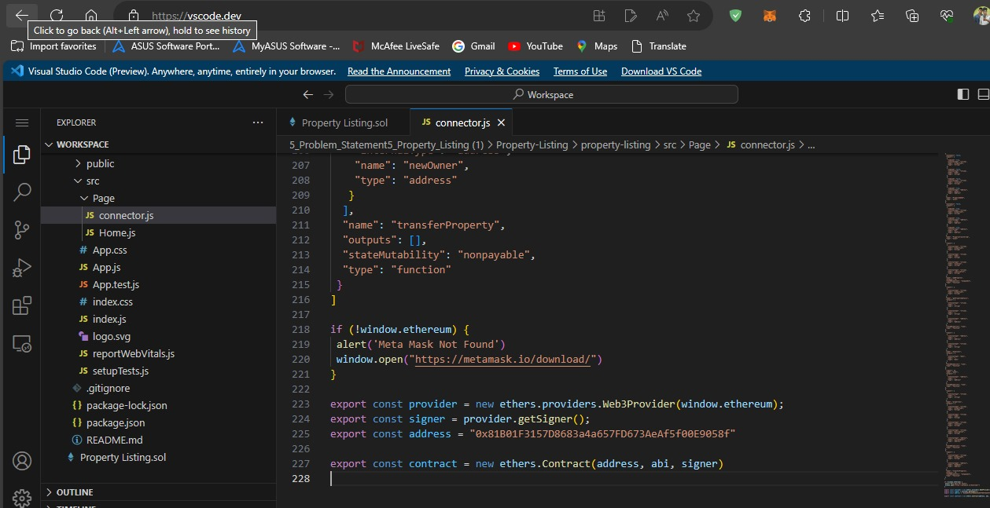

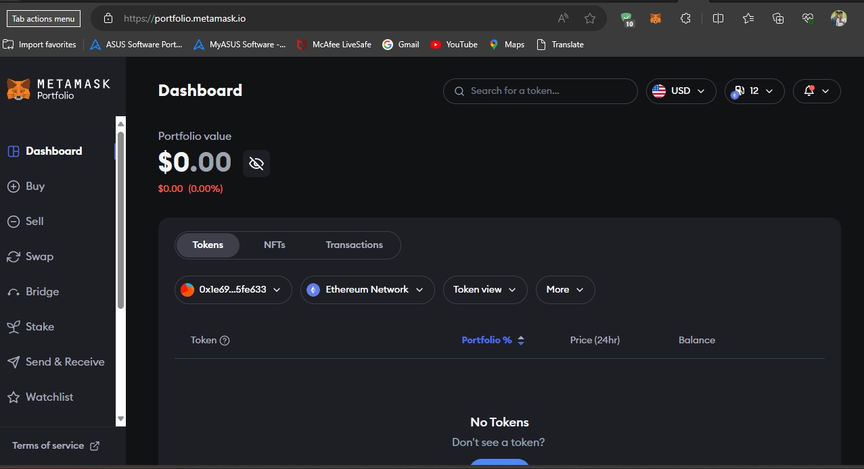

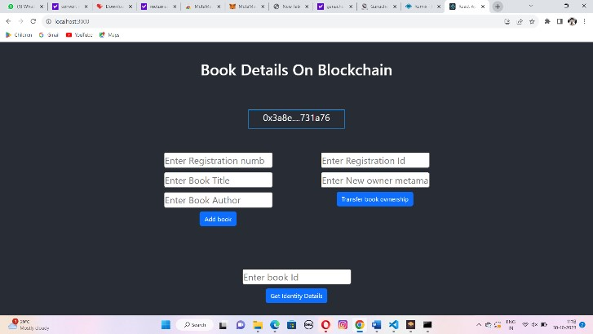

**10. ADVANTAGES AND DISADVANTAGES:**

**ADVANTAGES:**

Blockchain technology offers several advantages when applied to the real estate system. These advantages can enhance transparency, security, efficiency, and accessibility in the industry. Here are some of the key benefits:

Transparency and Immutability:

Blockchain's transparent and tamper-proof ledger provides an unalterable history of all transactions. Property records, titles, and agreements can be securely recorded and tracked on the blockchain, reducing the risk of fraud and disputes.

Reduced Intermediaries and Costs:

Blockchain can eliminate or reduce the need for intermediaries like real estate agents, title companies, and notaries. Smart contracts can automate processes, cutting down on fees and commissions, thus lowering transaction costs for buyers and sellers.

Efficient Transactions:

The use of smart contracts streamlines real estate transactions by automating various steps in the process. This leads to faster deal closures, reducing the time and effort involved in buying or selling a property.

Enhanced Security:

Blockchain's cryptographic features and consensus mechanisms make it highly secure. Property records and agreements are safeguarded against unauthorized access and tampering, ensuring data integrity and confidentiality.

Access to Verified Data:

Property information can be verified and cross-referenced on the blockchain. Buyers and sellers have access to accurate and up-to-date information about properties, reducing the chances of purchasing a disputed or misrepresented property.

Fractional Ownership:

Blockchain enables fractional ownership, allowing multiple investors to own a portion of a property. This opens up real estate investment opportunities to a wider range of individuals.

Global Accessibility:

Blockchain transcends geographic boundaries, enabling investors to participate in international real estate markets with relative ease. This global reach can diversify investment portfolios.

Standardization:

Blockchain can promote standardization in the real estate industry, from data formats to smart contract templates. This uniformity simplifies processes and documentation, reducing errors and misunderstandings.

Data Efficiency:

Decentralized data storage ensures efficient data management and reduces redundancy. It enables a single, synchronized source of truth for all stakeholders.

Compliance and Regulatory Support:

Smart contracts can be programmed to automatically enforce compliance with local real estate regulations. This helps reduce legal risks and ensures adherence to regulatory requirements.

Market Transparency:

Blockchain platforms can provide data analytics on market trends, property values, and transaction history, empowering buyers and sellers with valuable market insights

Resilience to Data Loss:

Blockchain's distributed ledger ensures data is backed up across multiple nodes. This resilience to data loss minimizes the risk of losing critical property records.

**DISADVANTAGES**

While blockchain technology offers numerous advantages for the real estate system, it also comes with certain disadvantages and challenges that need to be considered. Here are some of the disadvantages of using blockchain in the real estate system:

Regulatory Challenges:

Real estate transactions are subject to a wide range of local and national regulations. Adapting blockchain solutions to meet these regulations can be complex and time-consuming.

Integration Complexity:

Transitioning from traditional systems to blockchain-based systems can be technically challenging and may require substantial changes to existing infrastructure and practices.

Limited Adoption:

The real estate industry is traditionally conservative and may be slow to adopt new technologies. The widespread acceptance of blockchain in real estate may take time.

Privacy Concerns:

While blockchain offers transparency, there can be concerns about data privacy. Property owners may not want all of their information to be publicly accessible on a blockchain.

Data Storage Costs:

Storing data on the blockchain can be expensive, especially as the volume of transactions and records increases. This cost can be a significant consideration for large-scale real estate applications.

Interoperability Issues:

Different blockchain networks and protocols may not be compatible with each other, leading to fragmentation in the blockchain ecosystem. This can complicate data sharing and communication between different networks.

Scalability Challenges:

As more real estate transactions move to blockchain networks, scalability can become an issue. Ensuring that the network can handle a high volume of transactions without congestion or delays is crucial.

Energy Consumption (Proof of Work):

In some blockchain networks that use Proof of Work (PoW) consensus mechanisms, significant energy consumption is a concern. This can lead to environmental and cost considerations, particularly for large-scale blockchain implementations.

Legal Enforcement of Smart Contracts:

While smart contracts automate many processes, enforcing them in a legal context may be challenging. Traditional legal systems may not recognize blockchain-based smart contracts, making dispute resolution difficult.

Education and User Adoption:

Blockchain technology may be unfamiliar to many participants in the real estate industry, leading to resistance and a learning curve. Educating and raising awareness among stakeholders is an ongoing challenge.

**11. CONCLUSION:**

The aim of this study was to determine the impact of applying the block chain technology to the real estate sector in the area of DHA in Karachi, Pakistan. For this, different models were explored, and a questionnaire was also filled by subjects who are either working in the real estate sector in DHA or are investors ad well subjects who are using the block chain technology in their daily life. The conclusion that was derived was that although most of the respondents wanted technology to be implemented in this profitable sector of business, the people earning the most from the trading of these assets, the real estate brokers would rather not have this technology implemented in DHA as it would enable any new or old buyer or seller to see the prices at which these properties are being traded, which would cut into their profits as well as eventually make them redundant.

This study recommends that the government of Pakistan should take serious note and should apply the block chain technology to the real estate sector so that it is transparent in nature for the general population of the country as well as departments who are stakeholders in the real estate sector for the government so that these transactions can be taxed accurately, unlike the current system which is in place in DHA, Karachi.

This study was conducted in six months and due to the limitation of time, data on the real estate sector and resources, this study could only be conducted within an area in Karachi called Defense Housing Authority or DHA which has 8 phases with residential and commercial properties

**12**. **FUTURE SCOPE:**

The future scope of blockchain in the real estate industry is promising, and it is expected to revolutionize the way property transactions are conducted and managed. Here are some key aspects of the future scope of blockchain in real estate:

Streamlined Transactions: Blockchain will continue to simplify and expedite property transactions. Smart contracts will automate various steps in the process, reducing the time it takes to buy or sell a property.

Reduced Intermediaries: As blockchain adoption grows, the need for intermediaries such as real estate agents, title companies, and notaries may diminish. This will lead to cost savings for buyers and sellers.

Fractional Ownership: The tokenization of properties will become more common. This will enable fractional ownership, making it easier for a wider range of investors to participate in real estate markets.

Global Real Estate Investment: Blockchain will facilitate cross-border real estate investments. Investors will have the opportunity to diversify their portfolios by investing in properties located in different countries.

Transparency and Trust: Blockchain's transparency and tamper-proof nature will increase trust in the real estate market. Property records, titles, and agreements will be securely recorded and accessible to all stakeholders.

Security Against Fraud: Blockchain's cryptographic features and consensus mechanisms will make property records and agreements highly secure, protecting against fraud and tampering.

Market Analytics: Blockchain platforms will provide valuable data analytics on market trends, property values, and transaction history, empowering buyers and sellers with insights.

Standardization: Blockchain will promote standardization in the real estate industry, from data formats to smart contract templates. This will reduce errors and misunderstandings in transactions.

Efficient Data Management: Decentralized data storage will ensure efficient data management, reducing redundancy and errors while offering a synchronized source of truth for all stakeholders.

Compliance and Regulatory Support: Smart contracts will be programmed to automatically enforce compliance with local real estate regulations, reducing legal risks and ensuring adherence to regulatory requirements.

**13. APPENDIX:**

A decentralized, distributed ledger technology that records transactions in a tamper-resistant and transparent manner. Self-executing, code-based contracts that automatically execute and enforce the terms of an agreement.The process of representing real-world assets or rights as digital tokens on a blockchain.

The method by which agreement is reached on the validity of transactions and data in a blockchain network.: A process to verify the identity of participants in a financial transaction. Procedures and regulations designed to prevent the illicit use of funds through financial transactions. The distribution of authority, control, and data across a network without a central governing authority.The quality of data on a blockchain that cannot be altered or deleted. A consensus mechanism used in some blockchains where participants must solve complex mathematical puzzles to validate transactions. A consensus mechanism where validators are chosen to create new blocks and validate transactions based on the amount of cryptocurrency they hold and "stake" as collateral.The ability of different blockchain networks to work together and share d A digital representation of an asset or right on a blockchain.

Data Privacy: The protection and control of personal or sensitive data in a blockchain network. Services or mechanisms that provide external data to smart contracts on the blockchain.

YouTube link -https://youtu.be/rqfC68xa8DE?si=_qvpV-RBxiDPLbp3

GitHublink-https://github.com/Dineshsm-03/real-estate-management-system-NM2023TMID01014